

**CLOUD TECHNOLOGIES FOR BUSINESS**

**CA#1**

**Comprehensive Cloud Strategy for Fashion Hub Boutique**

**Group Members:**

Syed Taimoor Ali Shah (**20027698**)

Muhammad Marghoob Ahmad (**20036283**)

Pappala Sandeep (**20028293**)

Venkata Subbarao Tumati (**20017250**)

Github Link: [Tvirus01/Fashion-Hub-Boutique: CA1 Cloud Technologies (github.com)](https://github.com/Tvirus01/Fashion-Hub-Boutique)

Table of Content

**Comprehensive Cloud Strategy for Fashion Hub Boutique** 1

1. Background of the Enterprise 2

Industry 2

Size of the Business 2

Core Operations 2

Sales and Customer Support 2

Inventory Management 3

Marketing 3

E-commerce 3

**2. Current IT Setup** 3

Hardware 3

Software 3

Network Architecture 4

Other Components 4

**3. Recommendations** 4

Aspect 1: Servers and Compute Resources 4

Aspect 2: Storage Solutions 6

Aspect 3: Networking 6

Aspect 4: Applications and Software 7

**4. Detail the Costs** 8

Monthly Costs 8

Backup Options 8

Monitoring and Management 8

Total Estimated Monthly Cost 9

**5.** **Sample Cloud Infrastructure Deployment** 10

**6.** **Conclusion** 10

List of Figures

**Figure 1 12**

**Figure 2 13**

**Figure 3 13**

**Figure 4 14**

**Figure 5 14**

**Figure 6 15**

**Figure 7 16**

**Figure 8 16**

**Figure 9 17**

**Figure 10 17**

**Figure 11 18**

**Figure 12 18**

**Figure 13 18**

# **Comprehensive Cloud Strategy for Fashion Hub Boutique**

## **1. Background of the Enterprise**

### **Industry**

﻿In the retail region, Fashion Hub Boutique runs a sequence of boutiques with an emphasis on upscale clothing and add-ons. The organisation offers upscale, designer items to a wealthy customer base. Fashion Hub Boutique takes splendid pleasure in providing a carefully selected assortment of high-stop merchandise, encompassing everything from luxurious handbags and garb to awesome jewellery and custom accessories.

The boutique places plenty of attention on the client enjoy, which ensures individualized care and meticulous attention to element, making it suited to discriminating customers looking for superb and advanced goods.

The organization has 5 upscale retail locations in foremost cities, all of which might be meant to offer a luxurious buying experience. To supplement its physical presence and attract a much broader international target market, Fashion Hub Boutique also runs a successful online commercial enterprise.

The business enterprise has fifty full-time personnel who paint tough to uphold the brand's stellar recognition. They consist of managers, sales representatives, and administrative team of workers. Fashion Hub Boutique, which generates around $10 million in sales annually, continues increasing by using its e-commerce platform and bodily storefronts to offer outstanding fashion studies.

### **Size of the Business**

Fashion Hub Boutique has:

* ﻿Employees: 50 full-time workforce individuals, which include income buddies, managers, and administrative personnel.
* Locations: Five boutique shops placed in most important cities.
* Revenue: An annual revenue of about $10 million.

### **Core Operations**

﻿The essential business operations of Fashion Hub Boutique contain quite a number important tasks that assure seamless operation and purchaser satisfaction in both its offline and online spaces. Encouraging sales boom and maintaining the brand's recognition depend closely on these operations.

### **Sales and Customer Support**

* ﻿When it comes to managing sales through each in-save and online channels, Fashion Hub Boutique shines. Whether consumers are shopping for on line or at one of the five boutique places, the income crew is committed to giving them a ideal experience. Prioritizing customer service approach that any questions or problems could be quickly resolved and tailor-made assist could be provided. The personnel are well-educated to provide incredible customer service, ensuring that every stumble upon with customers improves the whole purchasing enjoy and encourages repeat commercial enterprise.

### **Inventory Management**

* ﻿Fashion Hub Boutique has to have a steady deliver of high-give up fashion designer products at every of its diverse locations, which makes green inventory control essential. The business makes use of a complicated inventory control system to monitor stock stages in actual time on all of its on-line and retail places. This technology assists with demand forecasting and supply chain logistics management via guaranteeing that famous commodities are constantly in stock. Precise inventory manage optimizes the ratio of supply to call for by reducing overstocking and stockouts.

### **Marketing**

* ﻿Fashion Hub Boutique makes use of centered advertising campaigns to draw in and preserve clients. This accommodates specialized virtual and traditional advertising initiatives for the target marketplace of the boutique. The marketing team creates attractive promos, seasonal campaigns, and focused advertising tasks using statistics-driven insights. Influencer collaborations, email advertising, and social media are used to elevate logo recognition and interaction. Building a effective logo presence that appeals to the upscale target organization is the goal.

### **E-commerce**

* ﻿In addition to its real storefronts, Fashion Hub Boutique has a robust online business. The on line keep gives customers a simple option for purchasing by using supplying the equal high-end, fashion designer items which can be featured inside the boutiques. Easy-to-use capabilities like secure fee techniques, short order success, and person experience are all prioritized in the design of the e-commerce website. Fashion Hub Boutique's omni-channel strategy guarantees that it caters to the demands of its customers, irrespective of whether or not they decide on in-person or on line shopping.

## **2. Current IT Setup**

﻿The present IT infrastructure of Fashion Hub Boutique is made to assist the employer's severa sports on its internet site and at its five boutique locations. This configuration includes community structure, hardware, software program, and different critical elements that assure secure and green business enterprise operations.

### **Hardware**

﻿The Fashion Hub Boutique's hardware infrastructure consists of a whole lot of factors of sale (POS) structures, laptop and pc computer systems, and servers.

* **﻿**Two on-premises servers host the corporation internet site and inner applications. These servers manage databases, host the agency website, and perform internal apps which are necessary for every day operations. They also perform different vital business features.
* Computers: For every day work, personnel make use of thirty computer PCs and twenty laptops. These gadgets are vital for advertising and marketing campaigns, customer support, administrative obligations, and other organization operations.
* Point of Sale (POS) Systems: There are 75 POS structures in all, with 15 POS terminals in every of the five boutique shops. These terminals are critical for coping with stock at the factor of sale, processing income transactions, and making sure that customers have a seamless checkout system.

### **Software**

﻿Fashion Hub Boutique's software program infrastructure consists of enterprise apps, working systems, and an e-trade platform.

* **﻿Operating Systems:** Windows Server 2016 is the working gadget on the servers, providing a dependable and steady setting for website hosting apps and overseeing community services. Windows 10 powers the PCs and laptops, offering a consumer-friendly interface and interoperability with a massive variety of programs.
* **Business Applications:** The body of workers often uses QuickBooks for accounting and financial administration, a proprietary inventory control device for stock manipulate, and the Microsoft Office Suite for productiveness responsibilities. These programs are vital to daily operations considering that they assist manage some thing from financial information and stock levels to communications and documents.
* **﻿E-commerce Platform:** The on-line store runs on Magento. Fashion Hub Boutique is capable of efficaciously manage its on line inventory, behavior transactions, and handle purchaser family members thanks to this platform, which is renowned for its versatility and robust function set.

### **Network Architecture**

﻿Fashion Hub Boutique's community architecture is made to provide robust protection and reliable connection at every location.

* **﻿Routers and switches:** All of the device within the boutique stores and the principal workplace are linked through Cisco routers and switches. Effective facts waft and verbal exchange among gadgets and places are ensured by this configuration.
* **Firewalls:** To defend the network from out of doors assaults, Fortinet firewalls are deployed. Advanced security features together with content filtering, intrusion prevention, and stable VPN get entry to are presented by way of these firewalls.
* **VPN:** A VPN configuration is in an area to offer body of workers members safe faraway get right of entry to. Employees who ought to get right of entry to the organization network even as travelling or from foreign places should pay unique interest to this.

### **Other Components**

﻿In addition, Fashion Hub Boutique makes use of a number of other factors to enhance its IT device.

* **﻿Storage Solutions:** Local storage and backups are treated with the aid of Network Attached Storage (NAS) devices. All authorized customers at the network might also Truely utilize the centralized storage answer presented by using those gadgets.
* **Restore Points:** Manual backups are achieved on outside difficult discs. In order to guarantee that essential statistics is stored safe inside the occasion of hardware failure or information corruption, those backups are normally performed on a ordinary frequency.
* **Disaster Recovery:** Manual information healing from backups is the mainstay of the carefully geared up current catastrophe recovery methods. In the occasion of a sizable disaster, this process could not totally fulfill the needs of the organisation and can take a protracted length.

﻿To summarize, Fashion Hub Boutique's gift IT configuration combines traditional and on-premises technologies to meet its working necessities. Although the enterprise has benefited significantly from this infrastructure, there is still room for improvement, in particular within the areas of automation, scalability, and catastrophe restoration. Making the switch to a cloud-based infrastructure would possibly contend with these issues in addition to offer different advantages like multiplied flexibility, fee financial savings, and security.

## **3. Recommendations**

### **Aspect 1: Servers and Compute Resources**

#### **Cloud Solutions**

* ﻿IaaS: Scalable computing sources may be acquired the use of Azure Virtual Machines or Amazon EC2.
* PaaS: ﻿Amazon Elastic Beanstalk or Azure App Services for launching websites without having to address the underlying infrastructure.

#### **Non-Cloud Solutions**

* **﻿**On-Premises Servers: Introducing new, high-overall performance servers or updating modern-day ones.

#### **Advantages and Disadvantages**

* **Cloud Solutions**:
  + ﻿Pros: Advantages encompass low protection necessities, excessive availability, pay-as-you-cross value effectiveness, and scalability.
  + Cons: Reliance on net connectivity, ability latency troubles, and records safety worries.
* **Non-Cloud Solutions**:
  + ﻿Benefits encompass overall manage over hardware and independence from net get right of entry to.
  + Cons: Expensive prematurely costs, continuous protection, limited scalability.

#### **Recommendation and Justification**

#### **Recommendation**

Adopt IaaS (Amazon EC2 or Azure Virtual Machines).

#### **Justification**

﻿Given Fashion Hub Boutique's want for scalability and less protection, cloud solutions provide a greater flexible and value-effective alternative to traditional on-premises servers. Because pay-as-you-pass IaaS permits corporations to simplest pay for the offerings they really use, they can effectively manipulate operational prices. By scaling up or down operations in response to call for, this flexibility is needed to assure that the IT infrastructure can help enterprise development without necessitating exorbitant upfront expenses.

﻿High availability is also presented with the aid of cloud carrier providers with strong disaster recovery functions, along with AWS and Azure. Fashion Hub Boutique may leverage offerings like Amazon EC2 or Azure Virtual Machines to take benefit of short healing alternatives, computerized backups, and regional redundancy. These traits are vital for minimizing system outages and protective against statistics loss. Because of those skills, inner IT group of workers contributors may also cognizance on more strategic tasks in place of tedious infrastructure administration because their maintenance burden is substantially reduced. Taking everything into account, the agency's desires of price containment, scalability, and operational effectiveness are all aligned with the use of IaaS.

### **Aspect 2: Storage Solutions**

#### **Cloud Solutions**

* **Cloud Storage**: Amazon S3 or Azure Blob Storage for scalable and secure storage.

#### **Non-Cloud Solutions**

* **On-Premises Storage**: Upgrading existing NAS devices or adding new SAN solutions.

#### **Advantages and Disadvantages**

* **Cloud Solutions**:
  + ﻿Advantages: Scalability, durability, international accessibility, automatic backups.
  + Disadvantages: Ongoing fees, data switch expenses, dependency on net connectivity.
* **Non-Cloud Solutions**:
  + ﻿Advantages: One-time price, whole management over statistics.
  + Disadvantages: Limited scalability, excessive protection, and risk of records loss.

#### **Recommendation and Justification**

**Recommendation**: Use cloud storage (Amazon S3 or Azure Blob Storage). **Justification**: Solutions for cloud storage provide strong data protection features and scalability. Data security and availability are guaranteed by the automatic backups and worldwide accessibility, which is essential for Fashion Hub Boutique's operations.

### **Aspect 3: Networking**

#### **Cloud Solutions**

* **Cloud Networking**: AWS VPC or Azure Virtual Network to manage networking in the cloud.

#### **Non-Cloud Solutions**

* **Traditional Networking**: Maintaining and upgrading existing Cisco routers and switches.

#### **Advantages and Disadvantages**

* **Cloud Solutions**:
  + ﻿Advantages: Simplified community management, scalability, included safety functions.
  + Disadvantages: Complexity in hybrid setups, ability mastering curve.
* **Non-Cloud Solutions**:
  + ﻿Advantages: Familiarity, control over physical network setup.
  + Disadvantages: Scalability problems, excessive renovation costs.

#### **Recommendation and Justification**

#### **Recommendation**

Implement a hybrid networking solution.

#### **Justification**

﻿Fashion Hub Boutique may additionally steadily flow to the cloud whilst maintaining manipulation over crucial on-premises additives thanks to a hybrid networking solution. Because of its flexibility, this approach could use the advantages of both conventional and cloud networking.

Fashion Hub Boutique may additionally migrate much less vital and extra flexible additives of its IT infrastructure, such as generic apps and non-touchy statistics, to the cloud via installing region a hybrid answer. In the meantime, touchy facts and critical structures can also live on the website, ensuring regulatory compliance and maintaining management over vital enterprise strategies.

﻿This approach ensures an easy transition, minimizing capacity disruptions to current operations. It allows the employer to pilot and optimize cloud solutions before a full-scale implementation, reducing the chance associated with a direct and entire shift to the cloud.

﻿A hybrid community layout also provides redundancy and aids in scalability. Fashion Hub Boutique has a stable on-premises infrastructure for critical operations and can leverage the scalability of the cloud for its evolving desires. This mixture ensures excessive availability and commercial enterprise continuity by strengthening well-known resilience.

### **Aspect 4: Applications and Software**

#### **Cloud Solutions**

* **SaaS**: Office 365 for productivity tools, QuickBooks Online for accounting, and a cloud-based inventory management system.

#### **Non-Cloud Solutions**

* **On-Premises Software**: Continuing with existing software installations and upgrading as necessary.

#### **Advantages and Disadvantages**

* **Cloud Solutions**:
  + ﻿Advantages: Regular updates, accessibility from anywhere, reduced IT burden.
  + Disadvantages: Subscription charges, ability records privacy issues.
* **Non-Cloud Solutions**:
  + ﻿Advantages: One-time buy, complete manage over software.
  + Disadvantages: Manual updates, restricted accessibility, higher IT burden.

#### **Recommendation and Justification**

**Recommendation**: Transition to SaaS solutions (Office 365, QuickBooks Online). **Justification**: ﻿SaaS solutions improve productiveness and lighten Fashion Hub Boutique's IT load through supplying regular updates and accessibility from any location. This is in step with the organization's requirement for flexibility and effective resource control.

## **4. Detail the Costs**

﻿A thorough rationalization of the predicted month-to-month costs for moving Fashion Hub Boutique to cloud answers can be found on this section. Compute resources, garage selections, networking, apps and software, backup plans, and tracking and administration are some of the regions into which the expenditures are separated.

### **Monthly Costs**

#### **Cloud Solutions**

1. **Compute Resources (IaaS)**
   * **Amazon EC2**: Approx. $200/month for a small instance.
   * **Azure VMs**: Approx. $210/month for a similar configuration.
2. **Storage Solutions**
   * **Amazon S3**: Approx. $50/month for 1TB storage.
   * **Azure Blob Storage**: Approx. $48/month for 1TB storage.
3. **Networking**
   * **AWS VPC**: Included in the cost of EC2.
   * **Azure Virtual Network**: Included in the cost of VMs.
4. **Applications and Software (SaaS)**
   * **Office 365**: $12.50/user/month. For 50 users: $625/month.
   * **QuickBooks Online**: $70/month for the essentials plan.

### **Backup Options**

* **Amazon S3 Glacier**: Approx. $4/month for 1TB for long-term backup.
* **Azure Backup**: Approx. $5/month for 1TB backup.

### **Monitoring and Management**

* **AWS CloudWatch**: Approx. $10/month for basic monitoring.
* **Azure Monitor**: Approx. $15/month for basic monitoring.

### **Total Estimated Monthly Cost**

* **Compute Resources**: $200 (AWS) or $210 (Azure).
* **Storage Solutions**: $50 (AWS) or $48 (Azure).
* **Applications and Software**: $695.
* **Backup Options**: $4 (AWS Glacier) or $5 (Azure Backup).
* **Monitoring and Management**: $10 (AWS CloudWatch) or $15 (Azure Monitor).

**Total (AWS)**: $639/month. **Total (Azure)**: $348/month.

﻿Amazon EC2 and Azure Virtual Machines are the recommended Infrastructure as a Service (IaaS) solutions for computing sources. A modest example on Amazon EC2 is anticipated to fee about $2 hundred a month, while an Azure Virtual Machine with a similar configuration will run you approximately $210 a month. These flexible and adaptable cloud-primarily based computing assets meet Fashion Hub Boutique's necessities by way of allowing changes in reaction to changing corporation needs without requiring huge upfront hardware investments.

The recommended alternatives for storage are Azure Blob Storage and Amazon S3. A 1TB storage plan on Amazon S3 is expected to cost about $50 a month and offers dependable, long-lasting storage that is accessible from anywhere in the world. For the same amount of storage, Azure Blob Storage is anticipated to cost around $48 per month. Fashion Hub Boutique's data is protected and readily available thanks to these cloud storage solutions, which also have built-in capabilities for improved data security and automated backups.

﻿The price of computing resources consists of networking charges. For instance, the fee of Amazon EC2 includes AWS Virtual Private Cloud (VPC), whilst the fee of Azure Virtual Machines includes Azure Virtual Network. This integration guarantees that the specified networking abilties are reachable without incurring additional costs, at the same time as additionally simplifying the general cost structure. These cloud networking answers provide effective connection and safety talents, permitting the flawless functioning of Fashion Hub Boutique's IT infrastructure.

﻿Moving to Software as a Service (SaaS) alternatives like Office 365 and QuickBooks Online is advised for apps and software. The monthly price of Office 365 is $12.50 for according to person. This works out to $625 a month for 50 customers, giving them get entry to to essential productivity equipment and encouraging teamwork in the course of the agency. The fundamental plan of QuickBooks Online, that is important for accounting and economic management, is expected to price $70 in step with month. Regular upgrades, faraway accessibility, and lessened IT administration responsibilities are some of the blessings that those SaaS solutions provide, guaranteeing that Fashion Hub Boutique personnel have access to the latest capabilities and resources.

﻿Options for backup are also taken into consideration; for lengthy-term backup requirements, Azure Backup and Amazon S3 Glacier are counseled selections. For 1TB of storage, Amazon S3 Glacier is anticipated to price about $4 consistent with month, making it an low cost alternative for long-time period data archiving. The fee of Azure Backup is a bit bit greater, at approximately $5 in keeping with month for 1TB of backup area. In the case of records loss or system screw ups, those solutions provide Fashion Hub Boutique secure and dependable ways to defend its important information and assure that backups are without problems available.

﻿To assure the ongoing and powerful functioning of the cloud infrastructure, tracking and administration expenses are also included. For basic tracking, AWS CloudWatch is predicted to price approximately $10 in line with month and provide actual-time insights into resource use and machine performance. Similarly, Azure Monitor is projected at roughly $15 in step with month for primary monitoring, delivering entire talents for measuring the fitness and performance of the cloud surroundings. These tracking tools are critical for retaining the IT infrastructure running at height efficiency and seeing feasible issues earlier than they affect operations.

﻿All things taken into consideration, Fashion Hub Boutique now has a scalable, low priced, and steady IT infrastructure thanks to the flow to cloud technologies. The corporation can correctly plan and price range for its IT wishes thanks to the aggressive projected costs that in reality illustrate the economic repercussions. The implementation of cloud generation is anticipated to reinforce Fashion Hub Boutique's operational efficiency and dependability, so bolstering its growth and ensuring a strong foundation for drawing close triumphs.

## **Sample Cloud Infrastructure Deployment**

Setup GitHub repo

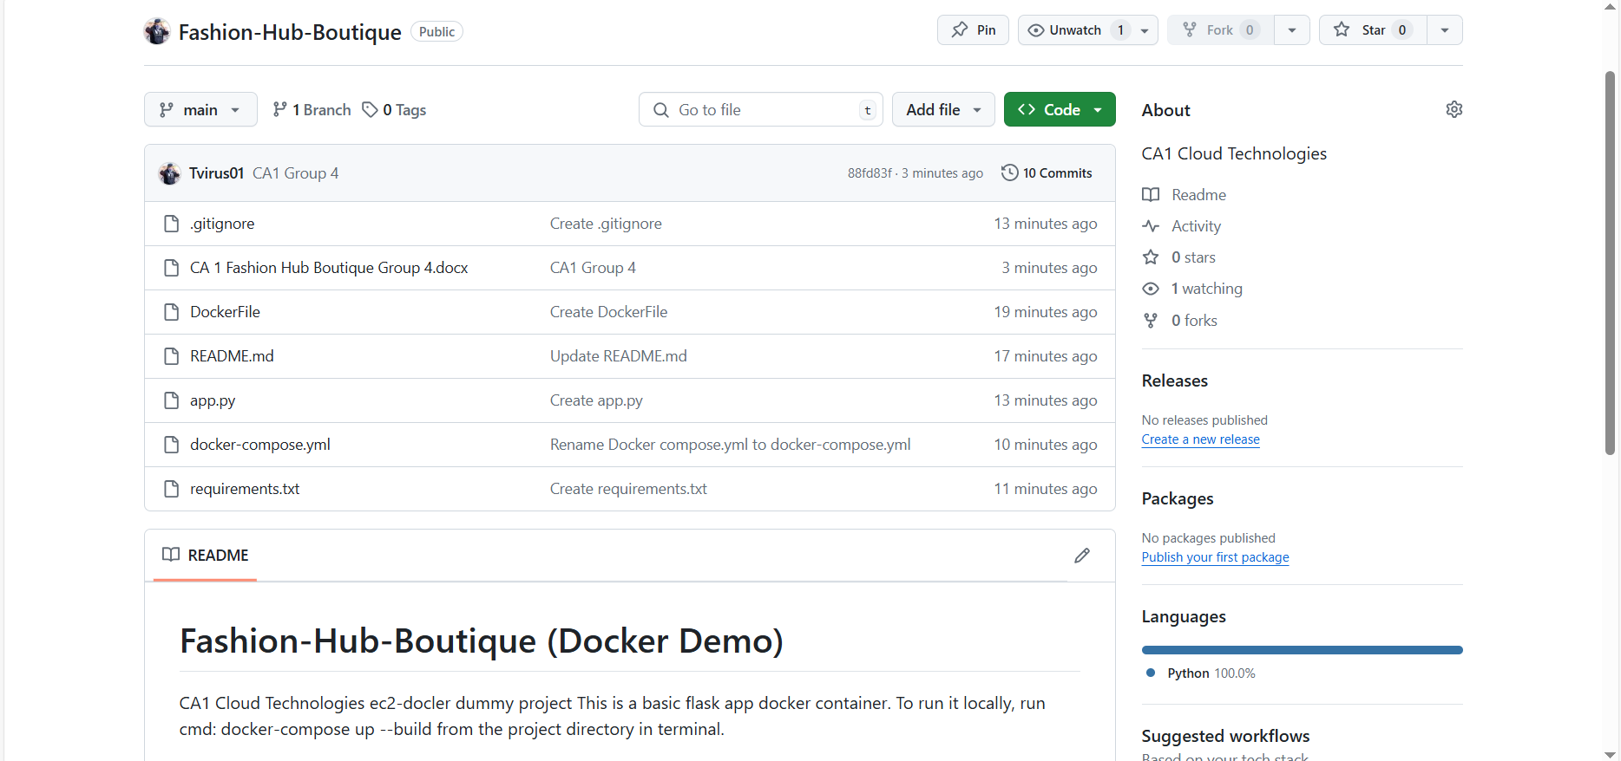

Figure 1

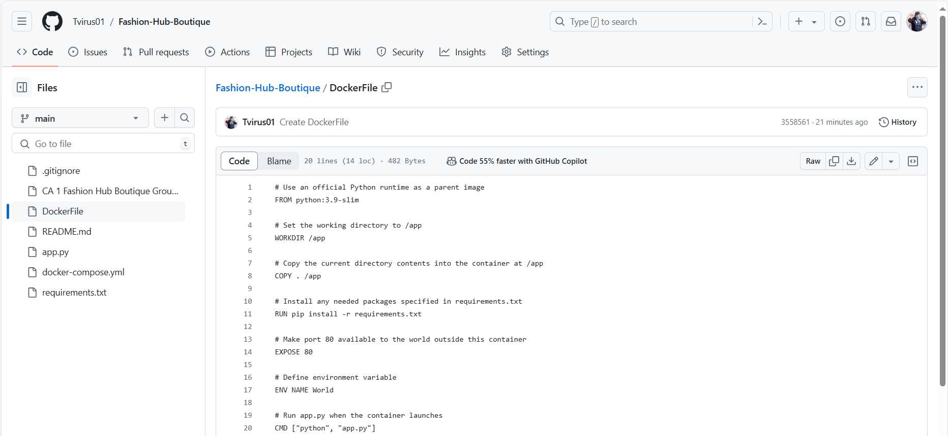

Figure 2

**Create EC Instance**

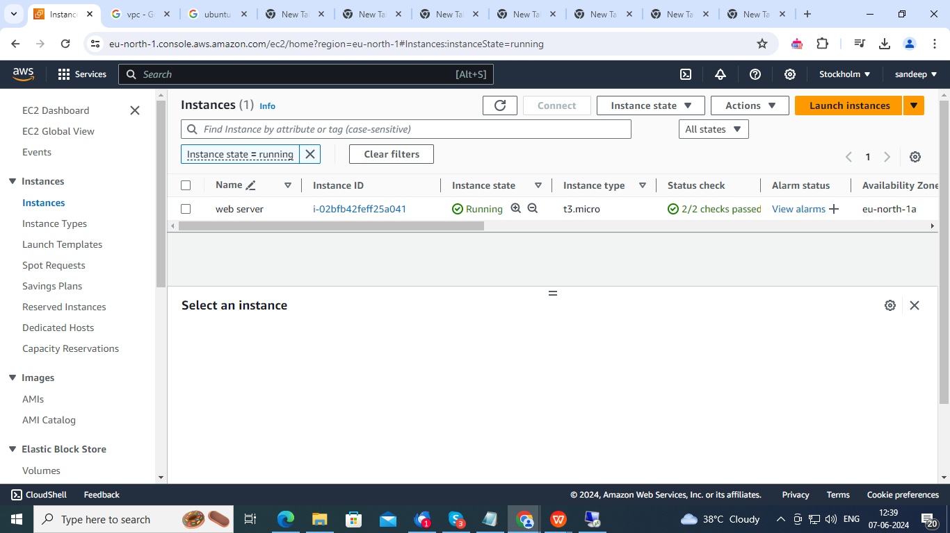

Figure 3

**Create a VPC**

* Create a VPC with a CIDR block, e.g., 10.0.0.0/16.
* Create subnets within the VPC

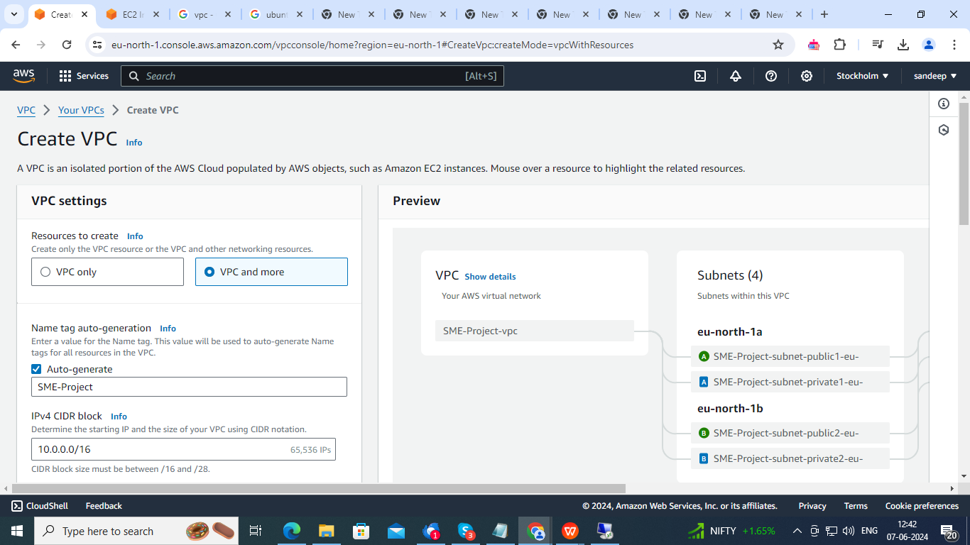

Figure 4

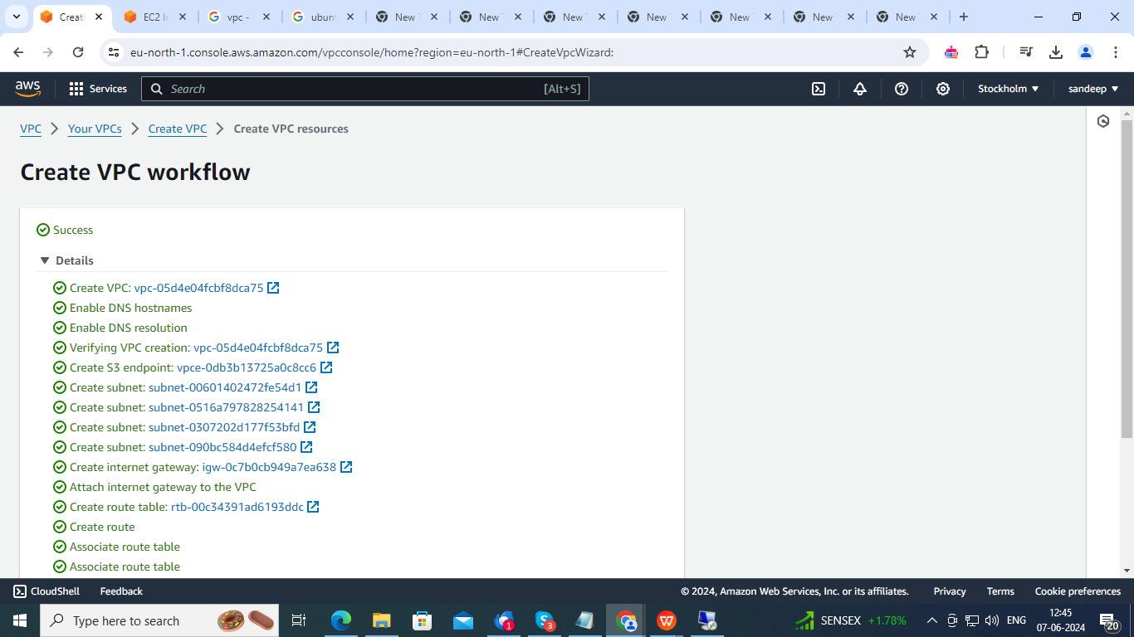

Figure 5

**Launch EC2 Instances**

* Launch an EC2 instance in the public subnet for the web server.
* Launch another EC2 instance
* Create a security group for the web server allowing HTTP (port 80) and HTTPS (port 443) traffic.

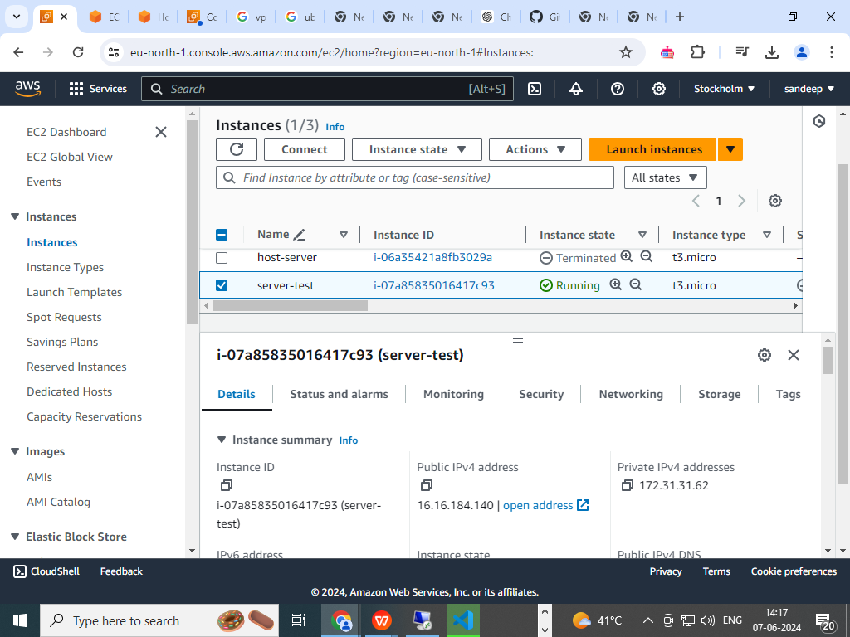

Figure 6

**Install Docker and Set Up Containers**

* SSH into the web server EC2 instance and install Docker.
* Pull and run an Apache Docker image.

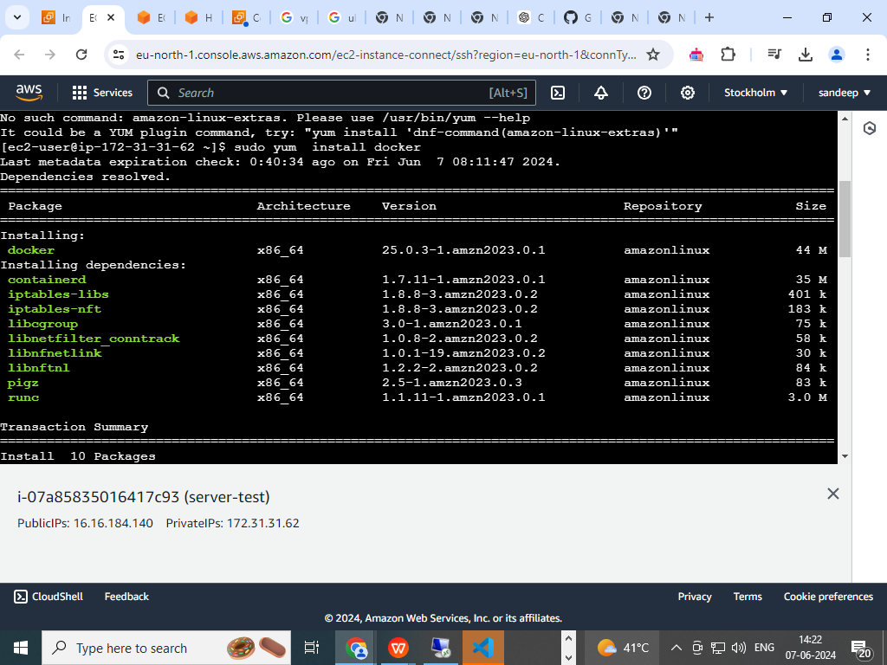

Figure 7

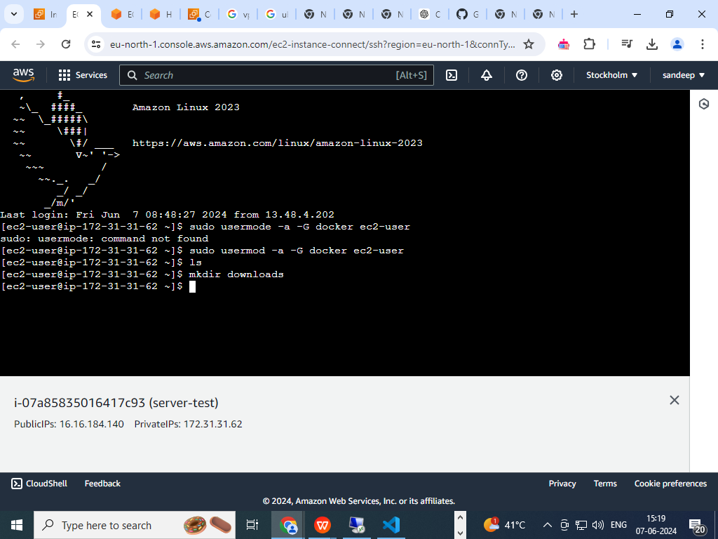

Figure 8

**Check Docker Status**

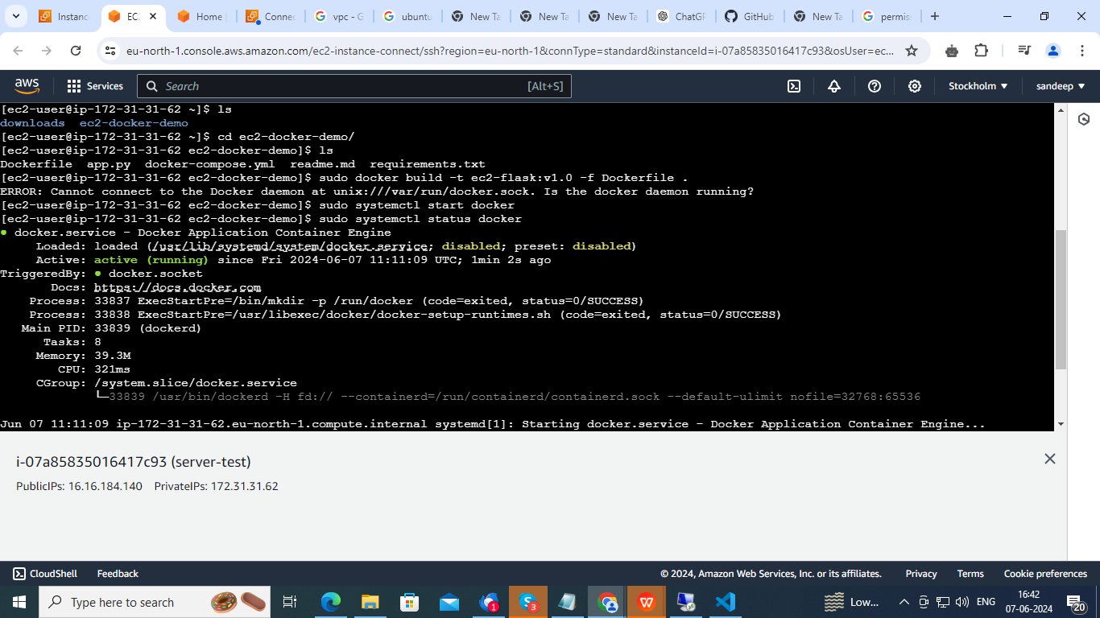

Figure 9

To run a Docker container with a Flask application on an EC2 instance, you can follow the steps below. The command you've provided sudo docker run -d -p 80:5000 ec2-flask:v1.0 will map port 5000 in the container to port 80 on the host machine and run the container in detached mode.

sudo docker run -d -p 80:5000 ec2-flask:v1.0

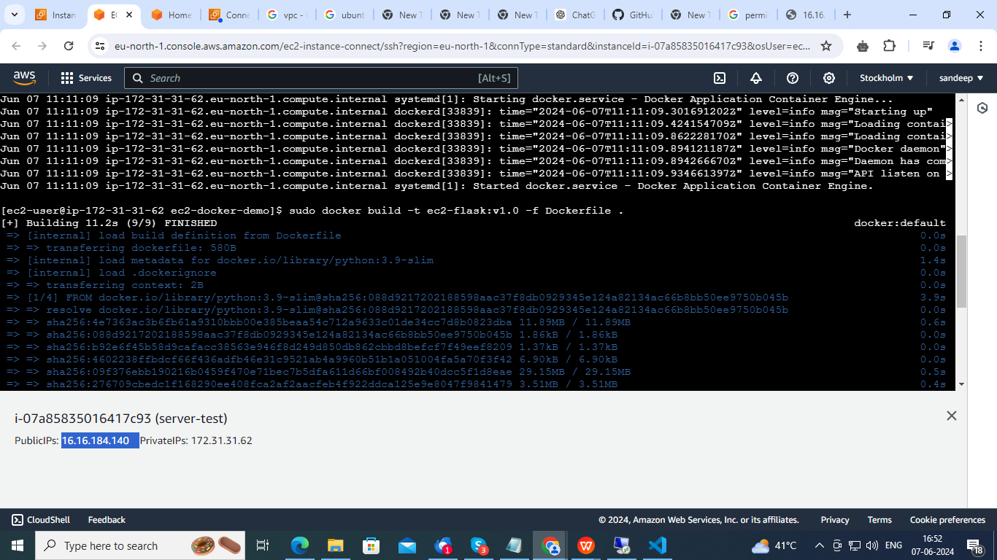

Figure 10

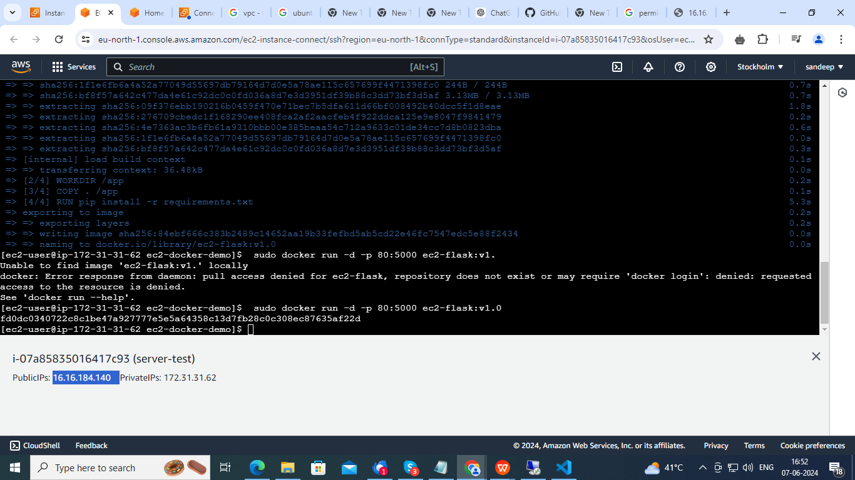

Figure 11

check if Application Successfully deployed



Figure 12

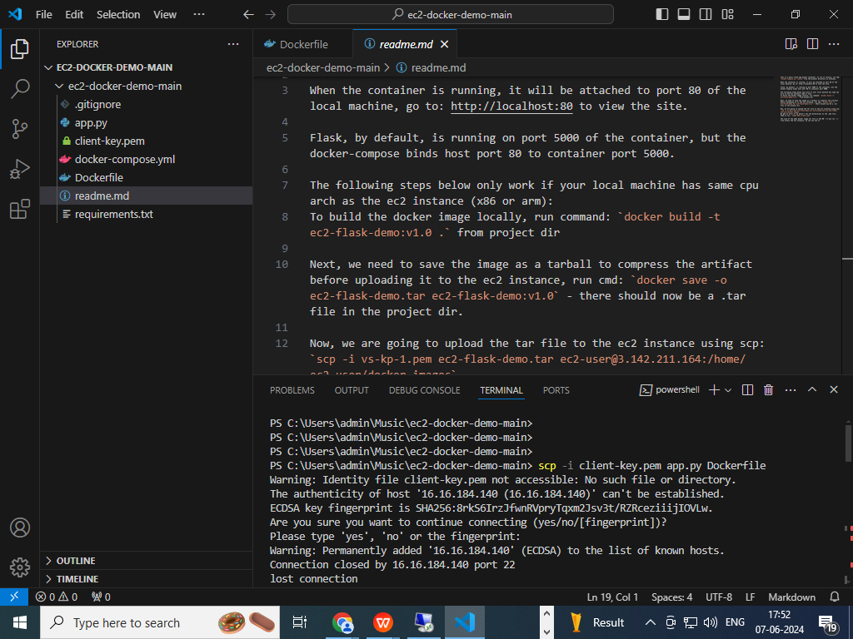

Figure 13

**Conclusion**

This document outlines Fashion Hub Boutique's cloud strategy, assesses the prevailing IT configuration, and offers guidelines for moving to cloud-based totally services. The cutting-edge IT infrastructure of Fashion Hub Boutique supports everyday operations with on-web page servers, desktop and laptop PCs, and factor-of-sale (POS) structures. The software structure includes Magento for e-commerce, QuickBooks, Windows Server 2016, Windows 10, Microsoft Office Suite, and a custom designed inventory control device. Cisco switches and routers, Fortinet firewalls, VPN configuration, NAS devices for local storage, and guide external difficult force backups are all a part of the community architecture. There aren't many catastrophe recovery strategies, even though.

﻿It is counselled to exchange to Infrastructure as a Service (IaaS) the usage of Amazon EC2 or Azure Virtual Machines and make use of cloud storage alternatives like Amazon S3 or Azure Blob Storage on the way to enhance the IT infrastructure. It's also encouraged to use a hybrid networking solution that mixes on-premises and cloud infrastructure and flow to Software as a Service (SaaS) services like Office 365 and QuickBooks Online. Cloud solutions offer scalability, value-performance, higher protection, excessive availability, and good-sized catastrophe recuperation options. By lowering IT administration obligations, this shift frees up the internal group to concentrate on key projects.

﻿To sum up, the usage of cloud solutions will improve Fashion Hub Boutique's IT infrastructure, facilitate enterprise expansion, and provide a stable, adaptable base for enterprise operations and consumer interactions.